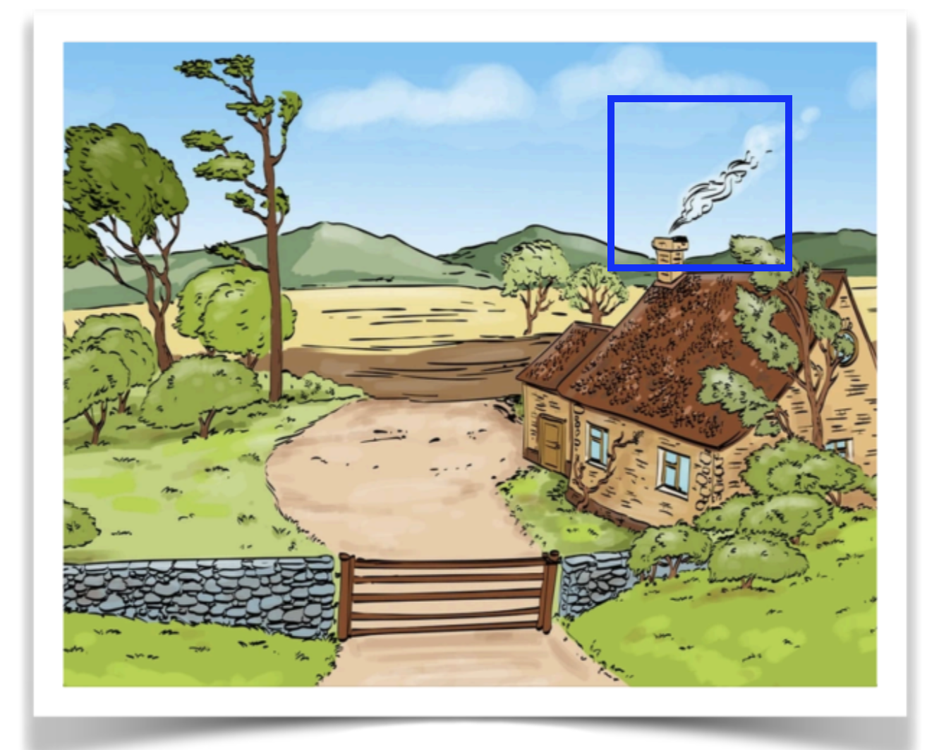

There is an inverse difference between the smoke from the chimney and the leaf from the tree.

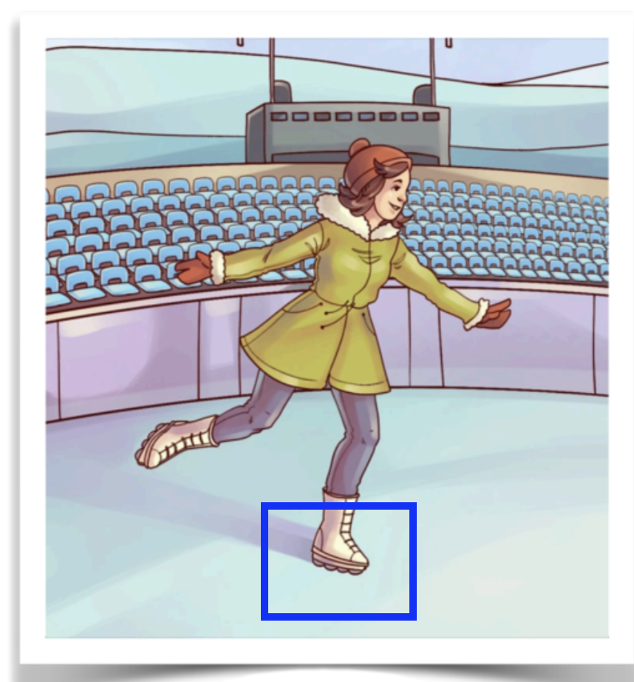

This woman wears roller skating shoes instead of ice skating shoes.

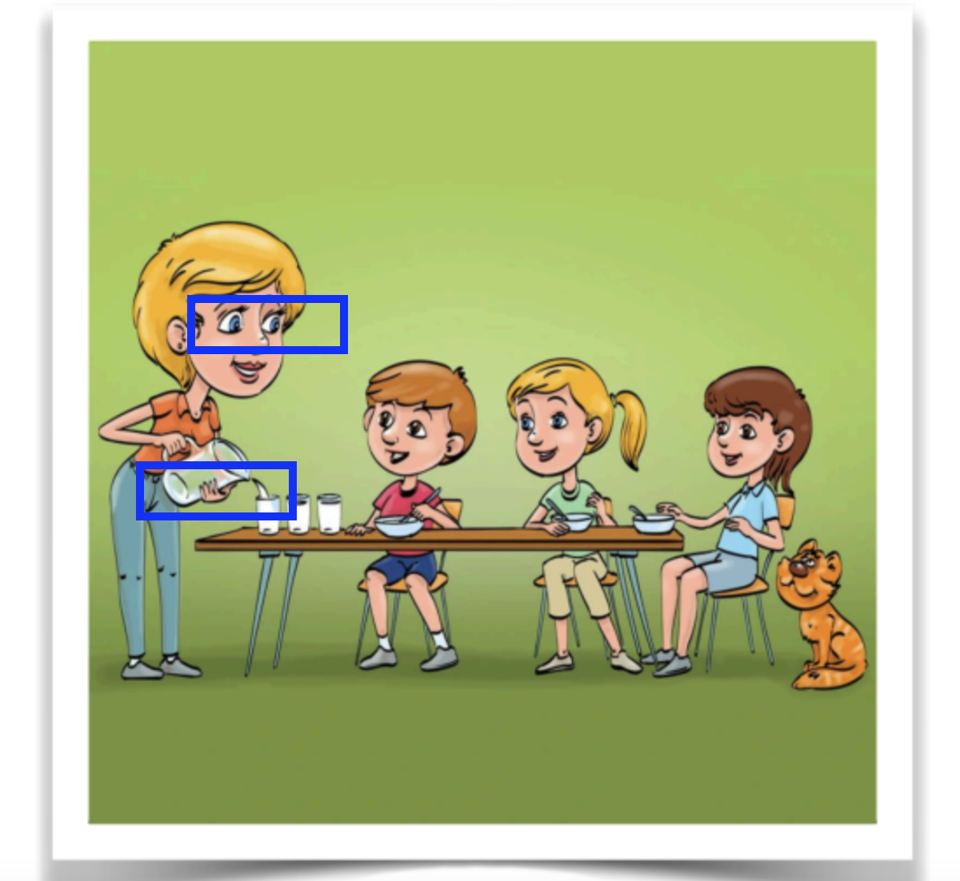

There are 2 points that I found:

1. The woman’s eyes are not looking at the glass where she is filling the water.
2. The woman is attempting to fill the glass with water, but the jar is empty.